QA For Additional Working Functionalities April 28
Dean:
- PROGRAM CHAIR QUESTIONS SHOULD BE APPROVED BY DEAN AND ASSOCIATE DEAN (Working)
- DEAN CANNOT APPROVE QUESTIONS FOR THEMSELVES (Working)
- SHOW ANSWER OPTION FOR ADDED QUESTIONS (Working)
- POP UP ERROR AND SUCCESS MESSAGE (Working)
- ONLY THE DEAN CAN ADD SUBJECT (Working)
- ADD 4 COURSE AND GENERAL SUBJECTS IN ADDING SUBJECT (Working)
- CREATE A DROP DOWN FOR SELECTING PROGRAM FOR SPECIFIC SUBJECT (Working)
- CANNOT ADD THE SAME SUBJECT AND CODE (Working)
- Create a Practice Exam Setting for generating questionnaires for the specific course. (Dili pa maka generate, silbi mao ni sya basehan para maka auto generate ug questionnaire) (Working)
- CREATE LIST VIEW FOR VIEWING QUESTIONS (Working)
- Approve, activate, or deactivate multiple users. (Working)
- Loading States (Working)
- Question info (created by, date created, date modified) (Working)
- Sidebar adjustments (Working)

User Used: Dean
23-A-12345
12345678
Program Chair:
- PROGRAM CHAIR CAN’T APPROVE ITS OWN QUESTIONS (Working)
- DEAN QUESTIONS MUST BE APPROVED BY PROGRAM CHAIR (Working)
- SHOW ANSWER OPTION FOR ADDED QUESTIONS (Working)
- POP UP ERROR AND SUCCESS MESSAGE (Working)
- CREATE LIST VIEW FOR VIEWING QUESTIONS (Working)
- Loading States (Working)
- Sidebar adjustments (Working)

User Used: Program Chair
23-A-12346
12345678

Faculty:
- SHOW ANSWER OPTION FOR ADDED QUESTIONS (Working)
- POP UP ERROR AND SUCCESS MESSAGE (Working)
- CREATE LIST VIEW FOR VIEWING QUESTIONS (Working)
- Loading States (Working)
- Sidebar adjustments (Working)

Bugs
User Used
23-A-12345
12345678

Submitted Questions but it the choices Changed in Pending Section

Steps to Replicate Bug:

Add a Question
Add Choices Then make the 2nd choice the Correct Answer
Submit Question
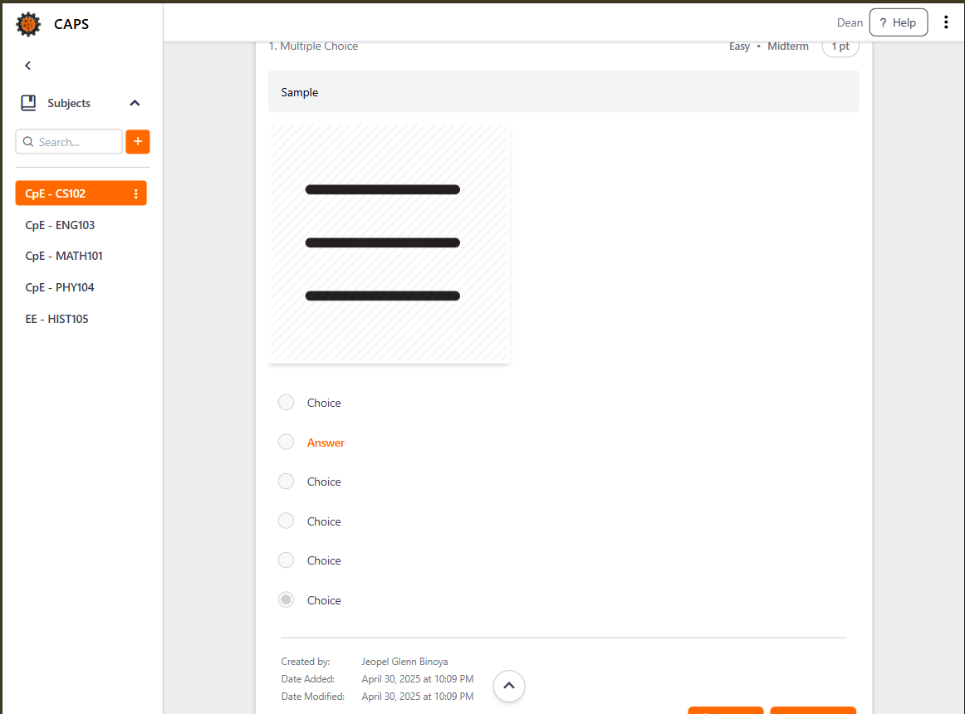
Go to the Pending, this is the Format

The Correct Answer Transferred to 6 but the colored one is still 2
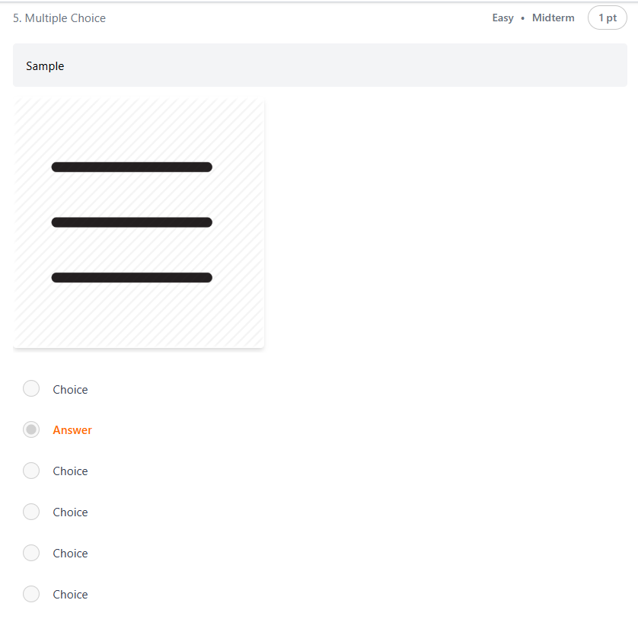
If the Problem is Approved it goes back to it’s original Format
This is the Original Format of the Question

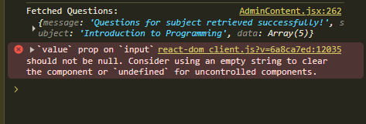
Bug Description:

